

Dear Customer,

Your Apple ID has been used from another device and location. We`ve temporarily **locked** your Apple ID for the protect account and the Apple Community.

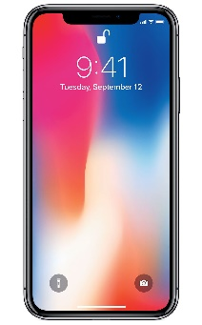**Login details :**

**iPhone X**

Country : Singapore

Operating System : iOS11

Browser : Safari

To continue enjoy our service.

You should to verify your identity and update your security settings to **Unlock your Apple ID**. If today you didn't verify your identity, your Apple ID will be locked for permanently. To complete the process, click the link below.

[**Verify your Account now**](http://x.co/Ktuzys)

Apple Support

Apple ID | Support | Privacy Policy

Copyright © 2018

Apple Distribution International, Hollyhill Industtial Estate, Hollyhill, Cork, Ireland. All Rights Reserved.